

Blue Prism Utility

Integration GUIDE

**Version: 1.0 for Blue Prism v6.6  
Document Revision: 1.0**



Contents

1. Introduction 3

2. Solution Overview 4

2.1. Included Visual Business Objects 4

2.2. Included Processes 5

3. Pre-Requisites and Environment Configuration 6

3.1. Additional VBOs 6

3.2. Blue Prism Credential 6

3.3. Version 8

4. Using the VBOs 9

4.1. Blue Prism v6.5 – Basic Actions 9

4.2. Blue Prism v6.5 – System Screen Actions 14

4.3. Blue Prism v6.5 – Credentials Actions 15

5. Using the Processes 45

5.1. Blue Prism v6.5 – Test Connection 45

5.2. Blue Prism v6.5 – Get All Credentials 46

5.3. Blue Prism v6.5 – Get Credential 47

5.4. Blue Prism v6.5 – Get All Access Rights 48

5.5. Blue Prism v6.5 – Add Access Rights 49

5.6. Blue Prism v6.5 – Remove Access Rights 50

5.7. Blue Prism v6.5 – Enable Credential 51

5.8. Blue Prism v6.5 – Disable Credential 52

5.9. Blue Prism v6.5 – Delete Credential 53

# Introduction

This set of Visual Business Objects (VBOs) and Processes provides methods for interacting with the Blue Prism interactive client. This guide will address how to use the VBOs and Processes.

# Solution Overview

This asset is comprised of the VBOs and Processes outlined below. The VBOs make up the core functionality of the asset as they interact with the Blue Prism interactive client itself. The Processes employ the VBOs to execute end-to-end processes (such as gathering all existing credentials which relies on many actions from the set of VBOs).

This asset has been built and tested for Blue Prism v6.6 (64-bit).

## Included Visual Business Objects

|  |  |
| --- | --- |
| VBO Name | Description |
| Blue Prism v6.6 – Basic Actions | Launches, signs in, navigates, signs out, and terminates the Blue Prism interactive client |
| Blue Prism v6.6 – System Actions | Navigates the tree of menu options available on the System screen |
| Blue Prism v6.6 – Credentials Actions | Navigates and interacts with the credentials in the Blue Prism Credential Manager |

## Included Processes

|  |  |
| --- | --- |
| VBO Name | Description |
| Blue Prism v6.6 – Test Connection | Tests a successful connection to Blue Prism by launching and terminating a new instance of Blue Prism |
| Blue Prism v6.6 – Get Credential | Retrieves a single credential and its currently enabled Access Rights |
| Blue Prism v6.6 – Get All Credentials | Retrieves a collection of all existing credentials and their currently enabled Access Rights |
| Blue Prism v6.6 – Get All Access Rights | Retrieves a collection of all available access rights in Blue Prism |
| Blue Prism v6.6 – Enable Credential | Enables a credential (by unchecking the Mark As Invalid checkbox) |
| Blue Prism v6.6 – Disable Credential | Disables a credential (by checking the Mark As Invalid checkbox) |
| Blue Prism v6.6 – Add Access Rights | Adds access rights to a credential |
| Blue Prism v6.6 – Remove Access Rights | Removes access rights from a credential |
| Blue Prism v6.6 – Delete Credential | Deletes a credential |

# Pre-Requisites and Environment Configuration

## Additional VBOs

This VBO leverages the following additional Blue Prism VBOs:

* Utility – Environment
* Utility – File Management
* Utility – Collection Manipulation

Ensure these VBOs are imported into your Blue Prism environment, otherwise exceptions will be encountered.

## Blue Prism Credential

The Processes in this package rely on a Credential to be stored in the Blue Prism Credential Manager. The credential stored here should be a Blue Prism user that has administrative rights to interact with the Credential Manager. The credential is retrieved and used to sign in to the Blue Prism application.

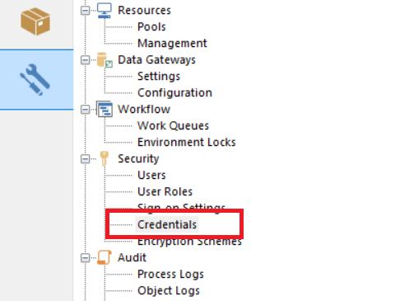

The details of the credential must be stored in the Blue Prism Credential Manager. Create a new “**General**” credential and populate the **Username** and **Password** with the Blue Prism user that should be used when executing the Processes in this package. The credential name will be accepted by the Processes as an input parameter and used to sign in to the Blue Prism interactive client.

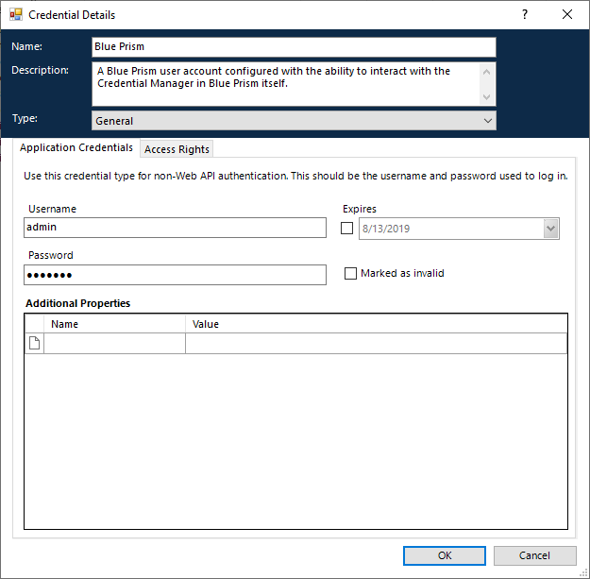

**NOTE:** You must set the ***Access Rights*** of the credential such that it can be accessed by the Processes included in this package.

## 3.3. Version

This asset has been built and tested for Blue Prism v6.6 (64-bit).

# Using the VBOs

Below are the available actions in each VBO and the details of the inputs and outputs that are available.

## Blue Prism v6.6 – Basic Actions

### Launch

This action launches a new instance of the Blue Prism interactive client. It must be called before any other action in any other VBO in this package. The action returns a Process ID.

Because this is a scenario where Blue Prism is automating itself, there will likely be more than one instance of Blue Prism running on the machine (one instance to execute these VBOs and a secondary instance of Blue Prism which these VBOs execute upon). The Process ID returned by this action is essential for subsequent actions in this VBO and other VBOs to identify the correct instance of Blue Prism to which to attach.

#### Inputs

N/A

#### Outputs

|  |  |  |
| --- | --- | --- |
| Parameter | Type | Description |
| Process ID | Number | The Windows Process ID (PID) of the newly launched instance of Blue Prism. |

### Sign In

This action signs into the launched instance of Blue Prism.

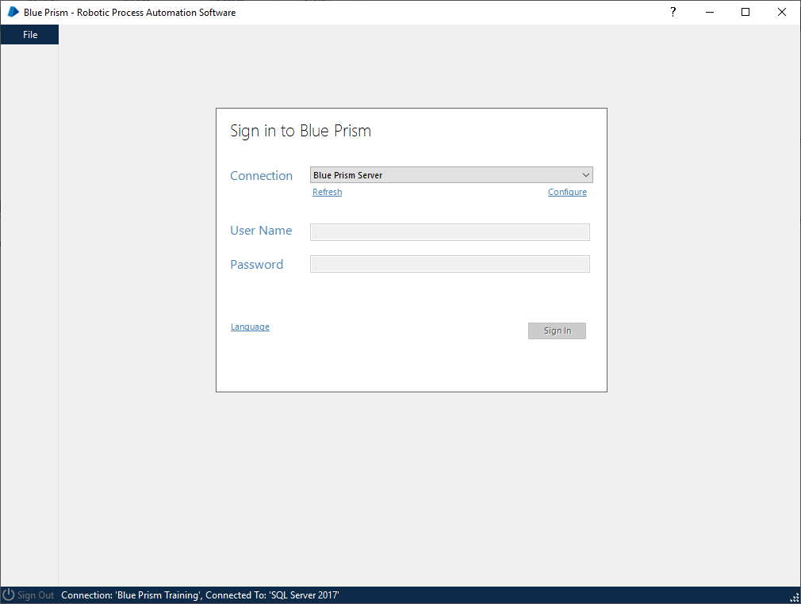

#### Inputs

|  |  |  |
| --- | --- | --- |
| Parameter | Type | Description |
| Connection Name | Text | The name of the connection to select from the “**Connection**” combo box on the sign-in screen. The spelling must match the value in the drop-down menu exactly. |
| Username | Text | The username to enter in to the **username** field. |
| Password | Password | The password to enter in to the **password** field. |
| Single Sign-On Enabled | Flag | If set to **True**, the username and password fields will be bypassed for environments where Single Sign-On (SSO) is set up. If set to **False**, the username and password fields will not be bypassed. The default value is **False**. |
| Process ID | Number | The Process ID of the Blue Prism Interactive Client to interact with. Retrieved from the Launch action. |

#### Outputs

N/A

### Navigate Interactive Client Tab Control

This action navigates the tab control at the top of the Blue Prism interactive client.



#### Inputs

|  |  |  |
| --- | --- | --- |
| Parameter | Type | Description |
| Tab Name | Text | The name of the tab control to click. Valid entries are: **Home**, **Studio**, **Control**, **Analytics**, **Releases**, **System**. |
| Process ID | Number | The Process ID of the Blue Prism Interactive Client to interact with. Retrieved from the Launch action in the Basic Actions VBO. |

#### Outputs

N/A

### Sign Out

This action clicks the Sign Out button on the Blue Prism interactive client.

#### Inputs

|  |  |  |
| --- | --- | --- |
| Parameter | Type | Description |
| Process ID | Number | The Process ID of the Blue Prism Interactive Client to interact with. Retrieved from the Launch action in the Basic Actions VBO. |

#### Outputs

N/A

### Terminate

This action terminates the Blue Prism interactive client.

#### Inputs

|  |  |  |
| --- | --- | --- |
| Parameter | Type | Description |
| Process ID | Number | The Process ID of the Blue Prism Interactive Client to interact with. Retrieved from the Launch action in the Basic Actions VBO. |

#### Outputs

N/A

## Blue Prism v6.6 – System Screen Actions

### Select System Menu Item

This action clicks an option from the tree of options on the System screen.

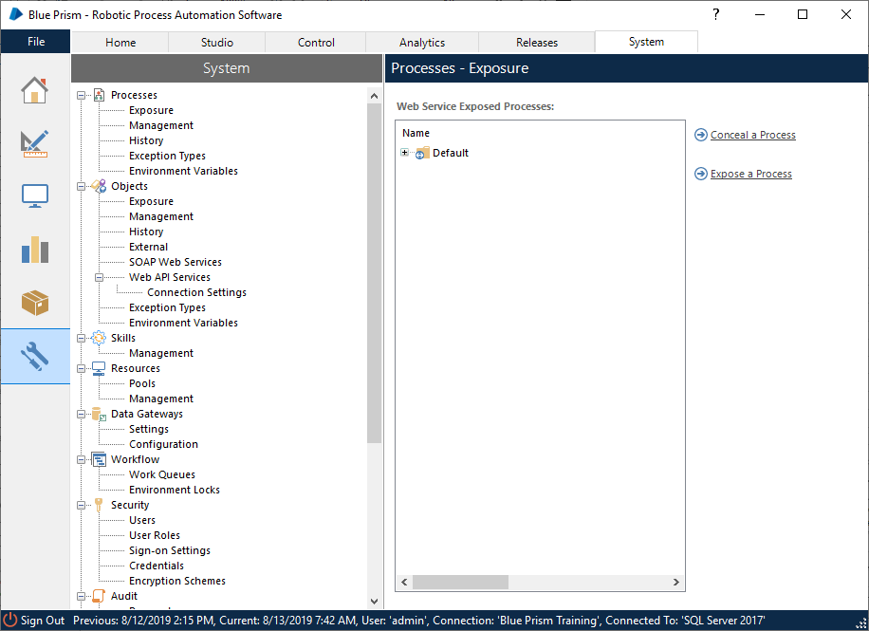

#### Inputs

|  |  |  |
| --- | --- | --- |
| Parameter | Type | Description |
| Option Name | Text | **Required** – The name of the option to select from the System menu tree. |
| Parent Name | Text | Optional – The name of the option **one level above** the Option Name specified above. |
| Process ID | Number | The Process ID of the Blue Prism Interactive Client to interact with. Retrieved from the Launch action in the Basic Actions VBO. |

Some options appear multiple times in the tree (e.g. “**Exposure**”). Specifying the **Parent Name** ensures the correct option is selected. If the **Option Name** is unique to begin with, a **Parent Name** is **not** required. If the **Option Name** is **not** unique and a **Parent Name** is **not** supplied, the action will attempt to select the first occurring instance of the option name.

**Example Usages:**

|  |  |  |  |
| --- | --- | --- | --- |
| Menu Option to Click | Option Name Value | Parent Name Value | Optional or Required |
| Objects > Exposure | Exposure | Objects | **Required** |
| Security > Credentials | Credentials | Security | **Optional** |
| Objects > Web API Services > Connection Settings | Connection Settings | Web API Services | **Optional** |

#### Outputs

N/A

## Blue Prism v6.6 – Credentials Actions

This object interacts with the various credentials and credential screens in Blue Prism

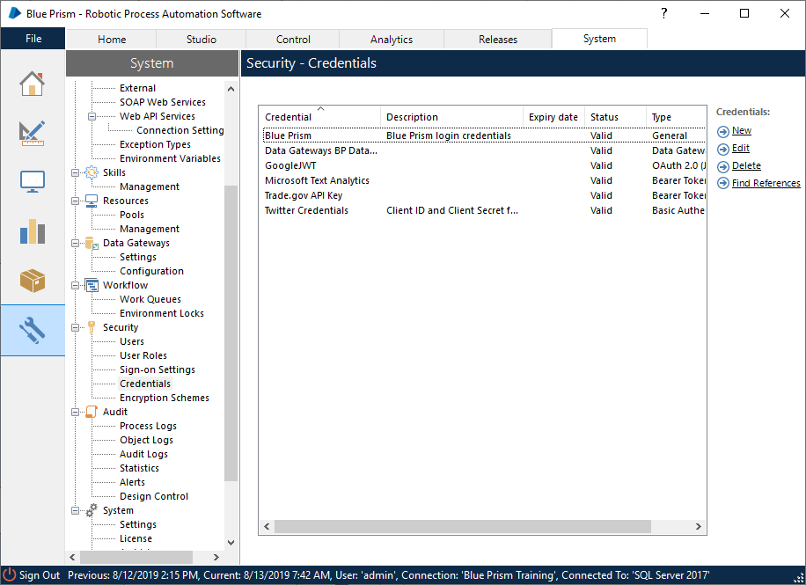

### Get All Credentials

This action returns a collection of basic information about all the credentials stored in Blue Prism. The collection fields returned include:

* Credential Name
* Description
* Expiry Date
* Status (valid or invalid)
* Credential Type

#### Inputs

N/A

#### Outputs

|  |  |  |
| --- | --- | --- |
| Parameter | Type | Description |
| Credentials | Collection | Collection of basic information about all credentials stored in Blue Prism |
| Process ID | Number | The Process ID of the Blue Prism Interactive Client to interact with. Retrieved from the Launch action in the Basic Actions VBO. |

### Get Credential

This action retrieves basic information about a single credential including the following fields:

* Credential Name
* Description
* Expiry Date
* Status (valid or invalid)
* Credential Type



#### Inputs

|  |  |  |
| --- | --- | --- |
| Parameter | Type | Description |
| Credential Name | Text | The name of the credential whose basic information should be retrieved |
| Process ID | Number | The Process ID of the Blue Prism Interactive Client to interact with. Retrieved from the Launch action in the Basic Actions VBO. |

#### Outputs

|  |  |  |
| --- | --- | --- |
| Parameter | Type | Description |
| Credential | Collection | Collection of basic information about the specified credential |

### Get Credential Type

This action retrieves the Type value for a specified Credential

#### Inputs

|  |  |  |
| --- | --- | --- |
| Parameter | Type | Description |
| Credential Name | Text | The name of the credential whose Type should be retrieved |
| Process ID | Number | The Process ID of the Blue Prism Interactive Client to interact with. Retrieved from the Launch action in the Basic Actions VBO. |

#### Outputs

|  |  |  |
| --- | --- | --- |
| Parameter | Type | Description |
| Credential Type | Text | The credential’s Type |

### Open Credential Details Screen for New Credential

This action opens the form to create a new credential by clicking the “**New**” button on the Credentials screen.

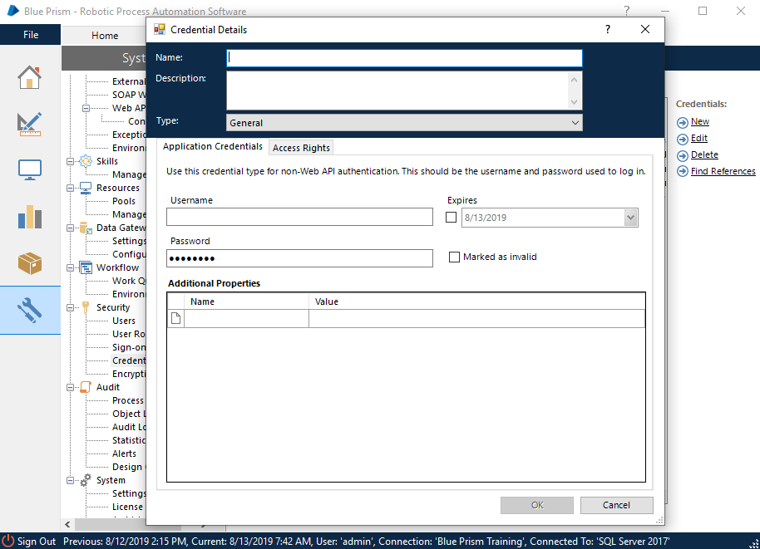

#### Inputs

|  |  |  |
| --- | --- | --- |
| Parameter | Type | Description |
| Process ID | Number | The Process ID of the Blue Prism Interactive Client to interact with. Retrieved from the Launch action in the Basic Actions VBO. |

#### Outputs

N/A

### Open Credential Details Screen for Existing Credential

This action opens the Credential Details screen for an existing credential by clicking the “**Edit**” button.

#### Inputs

|  |  |  |
| --- | --- | --- |
| Parameter | Type | Description |
| Credential Name | Text | The name of the credential to edit |
| Process ID | Number | The Process ID of the Blue Prism Interactive Client to interact with. Retrieved from the Launch action in the Basic Actions VBO. |

#### Outputs

N/A

### Open Delete Credential Screen

This action clicks the “**Delete**” button for a selected credential to open the Deletion Confirmation screen.

#### Inputs

|  |  |  |
| --- | --- | --- |
| Parameter | Type | Description |
| Credential Name | Text | The name of the credential to delete |
| Process ID | Number | The Process ID of the Blue Prism Interactive Client to interact with. Retrieved from the Launch action in the Basic Actions VBO. |

#### Outputs

N/A

### Click Delete Selected Items Button

This action clicks the “Delete Selected Items” button on the deletion confirmation screen for a credential.

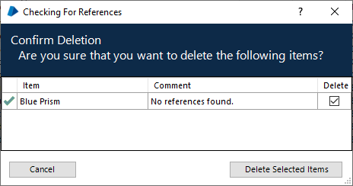

#### Inputs

|  |  |  |
| --- | --- | --- |
| Parameter | Type | Description |
| Process ID | Number | The Process ID of the Blue Prism Interactive Client to interact with. Retrieved from the Launch action in the Basic Actions VBO. |

#### Outputs

N/A

### Click OK Button on Credential Details Screen

This action clicks the OK button on the Credential Details screen (and thus, commits any changes that were made on the form).

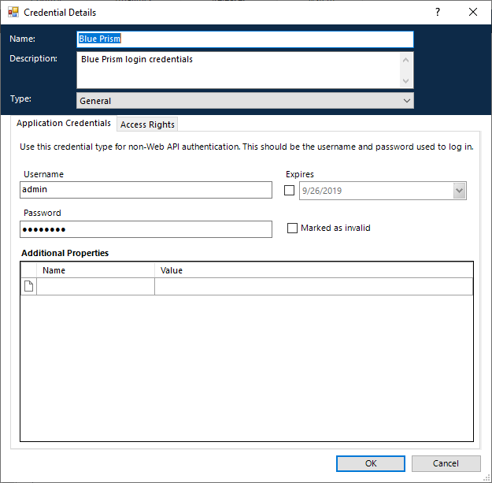

#### Inputs

|  |  |  |
| --- | --- | --- |
| Parameter | Type | Description |
| Process ID | Number | The Process ID of the Blue Prism Interactive Client to interact with. Retrieved from the Launch action in the Basic Actions VBO. |

#### Outputs

N/A

### Click Cancel Button on Credential Details Screen

This action clicks the Cancel button the Credential Details screen and thus discards any changes that may have been made to the form.



#### Inputs

|  |  |  |
| --- | --- | --- |
| Parameter | Type | Description |
| Process ID | Number | The Process ID of the Blue Prism Interactive Client to interact with. Retrieved from the Launch action in the Basic Actions VBO. |

#### Outputs

N/A

### Set Credential Name

This action sets the text in the Name field of the Edit Credential screen.

#### Inputs

|  |  |  |
| --- | --- | --- |
| Parameter | Type | Description |
| Process ID | Number | The Process ID of the Blue Prism Interactive Client to interact with. Retrieved from the Launch action in the Basic Actions VBO. |
| Name | Text | The name to enter in to the Name field on the Credential Details screen. |

#### Outputs

N/A

### Set Credential Description

This action sets the text in the Description field of the Edit Credential screen.

#### Inputs

|  |  |  |
| --- | --- | --- |
| Parameter | Type | Description |
| Process ID | Number | The Process ID of the Blue Prism Interactive Client to interact with. Retrieved from the Launch action in the Basic Actions VBO. |
| Description | Text | The description to enter in to the description field on the Credential Details screen. |

#### Outputs

N/A

### Set Credential Type

This action selects the Type in the Type combo box of the Edit Credential screen.

#### Inputs

|  |  |  |
| --- | --- | --- |
| Parameter | Type | Description |
| Process ID | Number | The Process ID of the Blue Prism Interactive Client to interact with. Retrieved from the Launch action in the Basic Actions VBO. |
| Type | Text | The Type to select from the Type combo box on the Credential Details screen. |

#### Outputs

N/A

### Set Credential Expiry Date

This action sets the Expiry Date in the Edit Credential screen.

#### Inputs

|  |  |  |
| --- | --- | --- |
| Parameter | Type | Description |
| Process ID | Number | The Process ID of the Blue Prism Interactive Client to interact with. Retrieved from the Launch action in the Basic Actions VBO. |
| Enable Expiry Date | Flag | Indicates whether an expiry date should be enabled. Set False to disable expiry date, set True to enable expiry date. |
| Expiry Date | Date | The expiry date to set. |

#### Outputs

N/A

### Set Credential Validity

This action sets checks or unchecks the Marked as Invalid checkbox in the Edit Credential screen.

#### Inputs

|  |  |  |
| --- | --- | --- |
| Parameter | Type | Description |
| Process ID | Number | The Process ID of the Blue Prism Interactive Client to interact with. Retrieved from the Launch action in the Basic Actions VBO. |
| Mark Credential Invalid | Flag | Indicates if the credential should be marked invalid. Set to True to mark credential invalid. Set to False to mark credential valid. |

#### Outputs

N/A

### Set Credential Username and Password

This action sets the Username and Password for credentials of type General, Basic Authentication, and Data Gateways Credentials.

#### Inputs

|  |  |  |
| --- | --- | --- |
| Parameter | Type | Description |
| Process ID | Number | The Process ID of the Blue Prism Interactive Client to interact with. Retrieved from the Launch action in the Basic Actions VBO. |
| Username | Text | The username to enter in to the username field on the Credential Details screen. |
| Password | Password | The password to enter in to the password field on the Credential Details screen |

#### Outputs

N/A

### Set Credential Client ID and Client Secret

This action sets the Client ID and Client Secret for credentials of type OAuth 2.0 (Client Credentials)

#### Inputs

|  |  |  |
| --- | --- | --- |
| Parameter | Type | Description |
| Process ID | Number | The Process ID of the Blue Prism Interactive Client to interact with. Retrieved from the Launch action in the Basic Actions VBO. |
| Client ID | Text | The Client ID to enter in to the Client ID field on the Credential Details screen. |
| Client Secret | Password | The Client Secret to enter in to the Client Secret field on the Credential Details screen. |

#### Outputs

N/A

### Set Credential Issuer and Private Key

This action sets the Issuer and Private Key for credentials of type OAuth 2.0 (JWT Bearer Token)

#### Inputs

|  |  |  |
| --- | --- | --- |
| Parameter | Type | Description |
| Process ID | Number | The Process ID of the Blue Prism Interactive Client to interact with. Retrieved from the Launch action in the Basic Actions VBO. |
| Issuer | Text | The issuer to enter in to the issuer field on the Credential Details screen. |
| Private Key | Password | The private key to enter in to the private key field on the Credential Details screen. |

#### Outputs

N/A

### Set Credential Token

This action sets the Token for credentials of type Bearer Token.

#### Inputs

|  |  |  |
| --- | --- | --- |
| Parameter | Type | Description |
| Process ID | Number | The Process ID of the Blue Prism Interactive Client to interact with. Retrieved from the Launch action in the Basic Actions VBO. |
| Token | Password | The token to enter in to the token field on the Credential Details screen. |

#### Outputs

N/A

### Navigate Credential Details Tab Control

This action selects either Application Credentials or Access Rights from the Credential Details Tab Control.

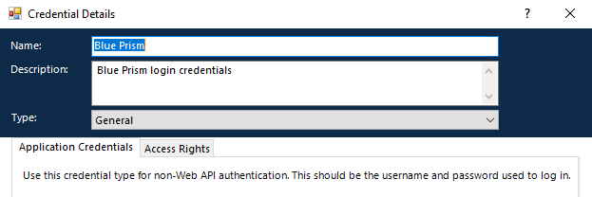

#### Inputs

|  |  |  |
| --- | --- | --- |
| Parameter | Type | Description |
| Process ID | Number | The Process ID of the Blue Prism Interactive Client to interact with. Retrieved from the Launch action in the Basic Actions VBO. |
| Tab Control Option | Text | The name of the tab to select. Valid entries are: **Application Credentials**, **Access Rights**. |

#### Outputs

N/A

### Navigate Access Rights Tab Control

This action clicks the tabs found within the Access Rights menu.

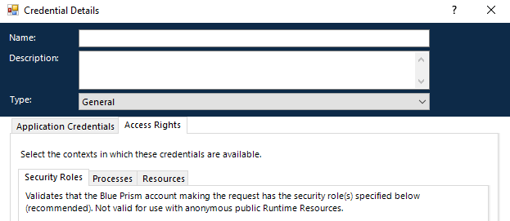

#### Inputs

|  |  |  |
| --- | --- | --- |
| Parameter | Type | Description |
| Process ID | Number | The Process ID of the Blue Prism Interactive Client to interact with. Retrieved from the Launch action in the Basic Actions VBO. |
| Access Right Tab Name | Text | The name of the tab to select. Valid entries are: **Security** **Roles**, **Processes**, **Resources**. |

#### Outputs

N/A

### Set Security Roles

This action checks or unchecks Security Roles on the Security Roles tab of the Access Rights menu.

#### Inputs

|  |  |  |
| --- | --- | --- |
| Parameter | Type | Description |
| Process ID | Number | The Process ID of the Blue Prism Interactive Client to interact with. Retrieved from the Launch action in the Basic Actions VBO. |
| Security Roles | Collection | A collection with two fields:  Name (Text): the name of the Security Role  Enabled (Flag): False to uncheck the role, True to check the role checkbox |

#### Outputs

N/A

### Set Processes

This action checks or unchecks Processes on the Processes tab of the Access Rights menu.

#### Inputs

|  |  |  |
| --- | --- | --- |
| Parameter | Type | Description |
| Process ID | Number | The Process ID of the Blue Prism Interactive Client to interact with. Retrieved from the Launch action in the Basic Actions VBO. |
| Processes | Collection | A collection with two fields:  Name (Text): the name of the Process  Enabled (Flag): False to uncheck the role, True to check the role checkbox |

#### Outputs

N/A

### Set Resources

This action checks or unchecks Resources on the Resources tab of the Access Rights menu.

#### Inputs

|  |  |  |
| --- | --- | --- |
| Parameter | Type | Description |
| Process ID | Number | The Process ID of the Blue Prism Interactive Client to interact with. Retrieved from the Launch action in the Basic Actions VBO. |
| Resources | Collection | A collection with two fields:  Name (Text): the name of the Resources  Enabled (Flag): False to uncheck the role, True to check the role checkbox |

#### Outputs

N/A

### Get Currently Enabled Security Roles

This action retrieves a list of enabled Security Roles from the Security Roles tab of the Access Rights menu.

#### Inputs

|  |  |  |
| --- | --- | --- |
| Parameter | Type | Description |
| Process ID | Number | The Process ID of the Blue Prism Interactive Client to interact with. Retrieved from the Launch action in the Basic Actions VBO. |

#### Outputs

|  |  |  |
| --- | --- | --- |
| Parameter | Type | Description |
| Enabled Security Roles | Collection | Collection containing the list of enabled Security Roles. |

### Get Currently Enabled Processes

This action retrieves a list of enabled Processes from the Processes tab of the Access Rights menu.

#### Inputs

|  |  |  |
| --- | --- | --- |
| Parameter | Type | Description |
| Process ID | Number | The Process ID of the Blue Prism Interactive Client to interact with. Retrieved from the Launch action in the Basic Actions VBO. |

#### Outputs

|  |  |  |
| --- | --- | --- |
| Parameter | Type | Description |
| Enabled Processes | Collection | Collection containing the list of enabled Processes. |

### Get Currently Enabled Resources

This action retrieves a list of enabled Resources from the Resources tab of the Access Rights menu.

#### Inputs

|  |  |  |
| --- | --- | --- |
| Parameter | Type | Description |
| Process ID | Number | The Process ID of the Blue Prism Interactive Client to interact with. Retrieved from the Launch action in the Basic Actions VBO. |

#### Outputs

|  |  |  |
| --- | --- | --- |
| Parameter | Type | Description |
| Enabled Resources | Collection | Collection containing the list of enabled Resources. |

### Get All Security Roles

This action retrieves a list of all Security Roles.

#### Inputs

|  |  |  |
| --- | --- | --- |
| Parameter | Type | Description |
| Process ID | Number | The Process ID of the Blue Prism Interactive Client to interact with. Retrieved from the Launch action in the Basic Actions VBO. |

#### Outputs

|  |  |  |
| --- | --- | --- |
| Parameter | Type | Description |
| All Security Roles | Collection | Collection containing the list of all Security Roles. |

### Get All Processes

This action retrieves a list of all Processes.

#### Inputs

|  |  |  |
| --- | --- | --- |
| Parameter | Type | Description |
| Process ID | Number | The Process ID of the Blue Prism Interactive Client to interact with. Retrieved from the Launch action in the Basic Actions VBO. |

#### Outputs

|  |  |  |
| --- | --- | --- |
| Parameter | Type | Description |
| All Processes | Collection | Collection containing the list of all Processes. |

### Get All Resources

This action retrieves a list of all Resources.

#### Inputs

|  |  |  |
| --- | --- | --- |
| Parameter | Type | Description |
| Process ID | Number | The Process ID of the Blue Prism Interactive Client to interact with. Retrieved from the Launch action in the Basic Actions VBO. |

#### Outputs

|  |  |  |
| --- | --- | --- |
| Parameter | Type | Description |
| All Resources | Collection | Collection containing the list of all Resources. |

# Using the Processes

## Blue Prism v6.6 – Test Connection

This process is used to ensure the connection to Blue Prism is working by launching and terminating an instance of Blue Prism.

### Inputs

N/A

### Outputs

N/A

## Blue Prism v6.6 – Get All Credentials

This process retrieves a collection of all existing credentials in Blue Prism as well as each credential’s currently enabled Access Rights.

### Inputs

|  |  |  |
| --- | --- | --- |
| Parameter | Type | Description |
| Sign-In Credential Name | Text | The name of the Credential stored in Blue Prism that contains a Blue Prism username and password. This credential is used to sign in to the launched instance of Blue Prism. |
| Sign-In Connection Name | Text | The name of the connection to be selected from the drop-down menu on the Blue Prism sign-in screen. |
| Single Sign-On | Flag | Set to True if the Blue Prism instance exists in a Single Sign-On environment and the username and password fields will be ignored. |

### Outputs

|  |  |  |
| --- | --- | --- |
| Parameter | Type | Description |
| Credentials | Collection | Contains the existing Blue Prism credentials and their access rights. |

## Blue Prism v6.6 – Get Credential

This process retrieves a collection of a single credential including its currently enabled Access Rights.

### Inputs

|  |  |  |
| --- | --- | --- |
| Parameter | Type | Description |
| Sign-In Credential Name | Text | The name of the Credential stored in Blue Prism that contains a Blue Prism username and password. This credential is used to sign in to the launched instance of Blue Prism. |
| Sign-In Connection Name | Text | The name of the connection to be selected from the drop-down menu on the Blue Prism sign-in screen. |
| Single Sign-On | Flag | Set to True if the Blue Prism instance exists in a Single Sign-On environment and the username and password fields will be ignored. |
| Credential Name | Text | The name of the credential for which information should be retrieved. |

### Outputs

|  |  |  |
| --- | --- | --- |
| Parameter | Type | Description |
| Credential | Collection | Contains the credential and its access rights. |

## Blue Prism v6.6 – Get All Access Rights

This action retrieves a collection of all available access rights in Blue Prism.

### Inputs

|  |  |  |
| --- | --- | --- |
| Parameter | Type | Description |
| Sign-In Credential Name | Text | The name of the Credential stored in Blue Prism that contains a Blue Prism username and password. This credential is used to sign in to the launched instance of Blue Prism. |
| Sign-In Connection Name | Text | The name of the connection to be selected from the drop-down menu on the Blue Prism sign-in screen. |
| Single Sign-On | Flag | Set to True if the Blue Prism instance exists in a Single Sign-On environment and the username and password fields will be ignored. |

### Outputs

|  |  |  |
| --- | --- | --- |
| Parameter | Type | Description |
| Access Rights | Collection | Contains all possible Access Rights within Blue Prism. |

## Blue Prism v6.6 – Add Access Rights

This process adds Access Rights to a single credential.

### Inputs

|  |  |  |
| --- | --- | --- |
| Parameter | Type | Description |
| Sign-In Credential Name | Text | The name of the Credential stored in Blue Prism that contains a Blue Prism username and password. This credential is used to sign in to the launched instance of Blue Prism. |
| Sign-In Connection Name | Text | The name of the connection to be selected from the drop-down menu on the Blue Prism sign-in screen. |
| Single Sign-On | Flag | Set to True if the Blue Prism instance exists in a Single Sign-On environment and the username and password fields will be ignored. |
| Credential Name | Text | The name of the credential for which access rights should be added. |
| SecurityRoles | Collection | Collection containing the Name of the Security Role to add and an Enabled value of True |
| Processes | Collection | Collection containing the Name of the Process to add and an Enabled value of True |
| Resources | Collection | Collection containing the Name of the Resource to add and an Enabled value of True |

### Outputs

N/A

## Blue Prism v6.6 – Remove Access Rights

This process removes Access Rights from a single credential.

### Inputs

|  |  |  |
| --- | --- | --- |
| Parameter | Type | Description |
| Sign-In Credential Name | Text | The name of the Credential stored in Blue Prism that contains a Blue Prism username and password. This credential is used to sign in to the launched instance of Blue Prism. |
| Sign-In Connection Name | Text | The name of the connection to be selected from the drop-down menu on the Blue Prism sign-in screen. |
| Single Sign-On | Flag | Set to True if the Blue Prism instance exists in a Single Sign-On environment and the username and password fields will be ignored. |
| Credential Name | Text | The name of the credential for which access rights should be removed. |
| SecurityRoles | Collection | Collection containing the Name of the Security Role to remove and an Enabled value of True |
| Processes | Collection | Collection containing the Name of the Process to remove and an Enabled value of True |
| Resources | Collection | Collection containing the Name of the Resource to remove and an Enabled value of True |

### Outputs

N/A

## Blue Prism v6.6 – Enable Credential

This process enables a credential by unchecking (if not already unchecked) the “Mark as invalid” checkbox on the Credential Details screen of a single credential.

### Inputs

|  |  |  |
| --- | --- | --- |
| Parameter | Type | Description |
| Sign-In Credential Name | Text | The name of the Credential stored in Blue Prism that contains a Blue Prism username and password. This credential is used to sign in to the launched instance of Blue Prism. |
| Sign-In Connection Name | Text | The name of the connection to be selected from the drop-down menu on the Blue Prism sign-in screen. |
| Single Sign-On | Flag | Set to True if the Blue Prism instance exists in a Single Sign-On environment and the username and password fields will be ignored. |
| Credential Name | Text | The name of the credential to be enabled. |

### Outputs

N/A

## Blue Prism v6.6 – Disable Credential

This process disables a credential by checking (if not already checked) the “Mark as invalid” checkbox on the Credential Details screen of a single credential.

### Inputs

|  |  |  |
| --- | --- | --- |
| Parameter | Type | Description |
| Sign-In Credential Name | Text | The name of the Credential stored in Blue Prism that contains a Blue Prism username and password. This credential is used to sign in to the launched instance of Blue Prism. |
| Sign-In Connection Name | Text | The name of the connection to be selected from the drop-down menu on the Blue Prism sign-in screen. |
| Single Sign-On | Flag | Set to True if the Blue Prism instance exists in a Single Sign-On environment and the username and password fields will be ignored. |
| Credential Name | Text | The name of the credential to be disabled. |

### Outputs

N/A

## Blue Prism v6.6 – Delete Credential

The process deletes an existing credential in Blue Prism.

### Inputs

|  |  |  |
| --- | --- | --- |
| Parameter | Type | Description |
| Sign-In Credential Name | Text | The name of the Credential stored in Blue Prism that contains a Blue Prism username and password. This credential is used to sign in to the launched instance of Blue Prism. |
| Sign-In Connection Name | Text | The name of the connection to be selected from the drop-down menu on the Blue Prism sign-in screen. |
| Single Sign-On | Flag | Set to True if the Blue Prism instance exists in a Single Sign-On environment and the username and password fields will be ignored. |
| Credential Name | Text | The name of the credential to be deleted. |

### Outputs

N/A